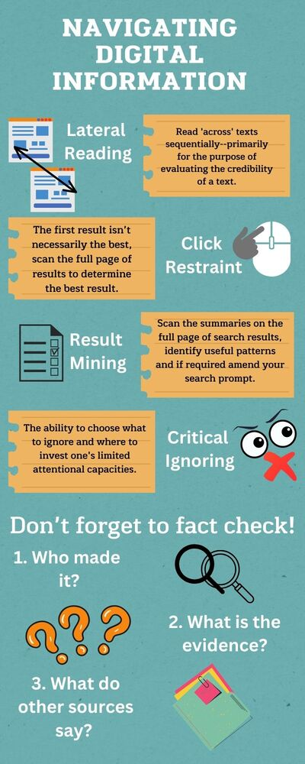

**What questions are still in your mind?**

**What element of the inquiry question do you think you need to conduct more research for? What information do you want to ‘fact check’ online?**

[Type here]

**What evidence do you have that reinforces this interpretation? – Summarise**

[Type here]

**From your reading of the source material what is your current historical interpretation?**

[Type here]

**Inquiry:** Why was Charlemagne crowned emperor in 800 CE and what impact did it have on Europe?

**INDEPENDENT RESEARCH**

|  |  |  |  |  |
| --- | --- | --- | --- | --- |
| **URL of Website** | **Who made it?**  *Can you identify them?*  *Do they seem credible?*  *Do they show bias?* | **What is the evidence?**  *Do they reference their evidence?*  *Can you fact check this evidence through lateral reading?* | **What do other sources say?**  *How do the sources from Part 1 corroborate or counteract this source?* | **Does this source convince you to change your historical interpretation? Why? Why not?** |
| [Type here] |  |  |  |  |
| [Type here] |  |  |  |  |
| [Type here] |  |  |  |  |